NIGERIAN CAPITAL DEVELOPMENT FUND (NCDF GROUP)
Board Charter
Board authority, mandate, composition, operating protocol and reserved matters
Institutional standard policy and framework document prepared for governance, investor diligence, and operational implementation across the NCDF Group ecosystem. This document is structured with reference to international good practice used by development finance institutions, including IFC-style governance, risk, and environmental and social management approaches.
Document owner | NCDF Group Board / Company Secretariat
Applies to | HoldCo, regulated entities, funds, SPVs, programmes and controlled subsidiaries
Review cycle | Annual review or earlier if triggered by material change
Reference architecture | IFC-style governance and control environment, OECD corporate governance principles, three-lines model, risk-based compliance

Executive summary
Board Charter establishes the minimum institutional standard for the NCDF Group in this domain. It is written for use by the Board, committees, executives, control functions, programme leaders, regulated entities, fund vehicles and project companies. The design intent is to create a governance document that can be used both operationally and in investor / DFI diligence, with clear authority, process, evidence standards and accountability.

Benchmark reference points
Reference point | How it informs NCDF documents
IFC-style governance and ESMS practice | Management-system orientation, risk-based controls, escalation and action planning.
G20/OECD corporate governance principles | Board stewardship, disclosure quality, shareholder rights and committee discipline.
Three lines model | Clear separation of ownership, oversight and assurance responsibilities.
Risk-based financial crime practice | Enhanced due diligence, sanctions screening, beneficial ownership review and suspicious activity escalation.

Framework diagram
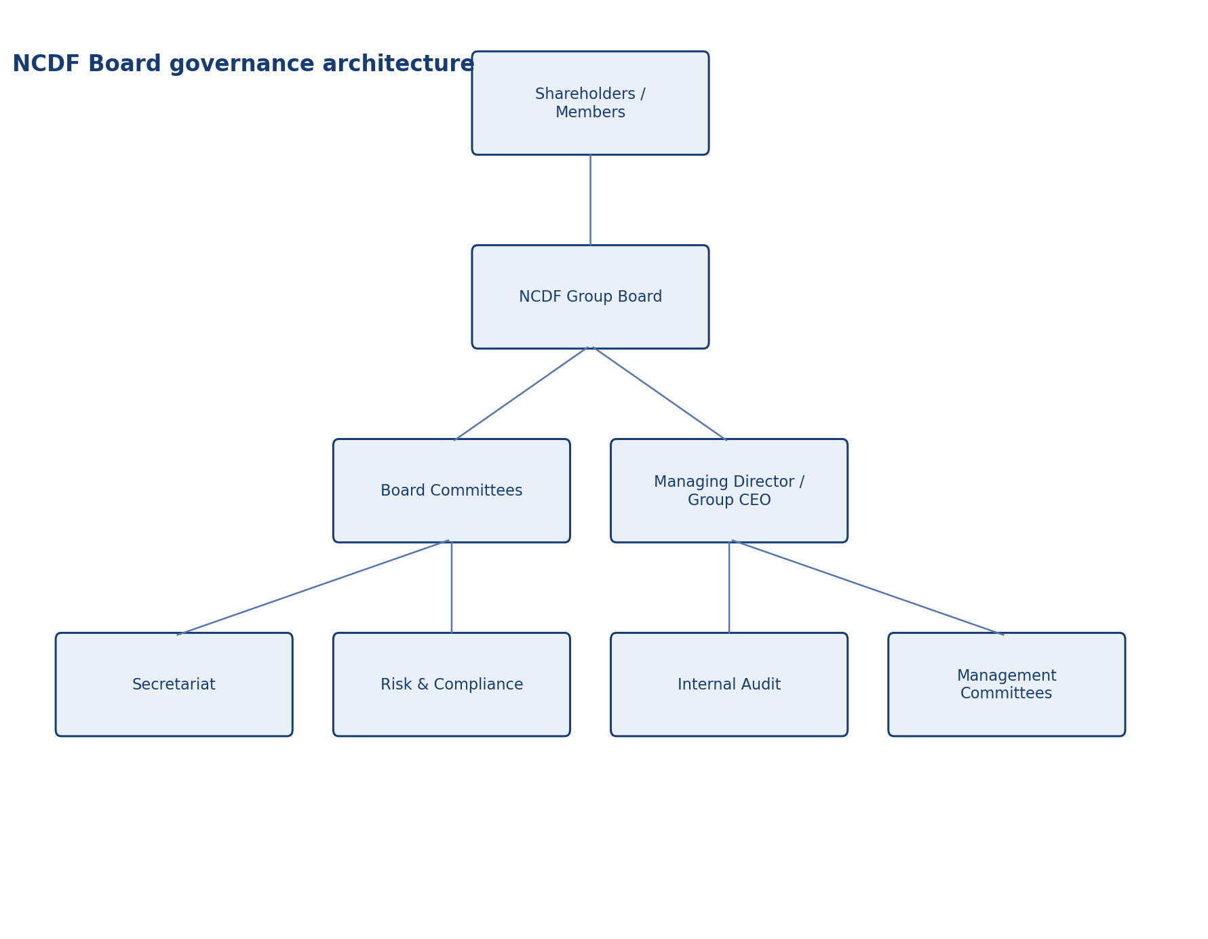
NCDF Board governance architecture

Scope and application
Unless expressly excluded in writing, this document applies to NCDF Holdings Limited, controlled subsidiaries, regulated entities, managed funds, project SPVs, corporate functions, country or state programmes, and staff or contractors acting on behalf of the Group. Where a fund constitution, shareholder agreement, regulatory licence or concession agreement imposes an additional requirement, management shall reconcile the difference in favour of the stricter or more specific control.

Authority and approval
This document is issued under the authority of the NCDF Group Board and, where applicable, applies through delegated authority to the Board committees, management committees, regulated entities, fund vehicles, special purpose vehicles and controlled subsidiaries. Where local law, fund documentation or regulatory licence conditions impose stricter requirements, the stricter standard prevails.

Definitions and interpretive principles
For the purposes of this document, 'Board' means the board of the relevant NCDF entity; 'Group' means NCDF Holdings Limited together with controlled entities, programmes and managed vehicles; 'material' means any matter that could reasonably influence an investor, regulator, counterparty or stakeholder decision; and 'three lines' refers to business ownership of risk, independent oversight, and independent assurance.

Purpose and mandate
The Board Charter defines the formal authority, responsibilities, operating model and behavioural expectations of the NCDF Group Board. It establishes how the Board provides strategic direction, fiduciary oversight and stewardship of capital across the Group’s holding company, regulated entities, managed funds, special purpose vehicles and affiliated programmes. The charter is designed for a complex development investment platform that must satisfy investor, regulatory and public-interest scrutiny.
• Provide a clear decision and control architecture that can withstand Board, auditor, regulator and investor scrutiny.
• Create consistent expectations across HoldCo, regulated entities, funds, SPVs and programmes.
• Reduce ambiguity, control bypass and key-person dependency through documented process and accountability.

Role of the Board
The Board is responsible for setting purpose and long-term direction; approving strategy, annual objectives and material capital allocation; appointing, supervising and, where appropriate, replacing the chief executive and other key officers; overseeing financial integrity, disclosure, internal control, risk and compliance; safeguarding the interests of shareholders and legitimate stakeholders; and ensuring that culture, conduct and incentives support prudent and responsible behaviour.
• Documented roles should be matched with formal authorities, information rights and reporting obligations.
• Committee or management forums should not duplicate or obscure Board accountability.
• Escalation routes should be explicit for urgent issues, threshold breaches, exceptions and incidents.

Reserved matters
Without prejudice to matters reserved by law or constitutional documents, the Board reserves to itself: approval of strategy and business plans; budget and capital plans; establishment or acquisition of funds, subsidiaries and SPVs; material investments, disposals and financings above delegated thresholds; appointments to Board committees and key control functions; approval of core policies and frameworks; approval of annual and interim financial statements; major litigation, settlements and enforcement matters; and transactions involving conflicts of interest or related parties.

Composition and independence
The Board shall comprise a balanced mix of executive, non-executive and, where appropriate, independent directors possessing expertise in finance, infrastructure, sustainability, healthcare, housing, legal and regulatory matters, public-private partnership structuring, technology and institutional governance. The Chair shall lead the Board and ensure effective contribution by all directors. Independence shall be assessed at least annually against objective criteria, including absence of management responsibility, material advisory or commercial dependency, and ability to exercise unbiased judgement.
• Documented roles should be matched with formal authorities, information rights and reporting obligations.
• Committee or management forums should not duplicate or obscure Board accountability.
• Escalation routes should be explicit for urgent issues, threshold breaches, exceptions and incidents.

Director duties and standards of conduct
Each director shall act in good faith, with due care, skill and diligence, in the best interests of the relevant NCDF entity while considering the broader long-term sustainability of the Group. Directors shall prepare adequately, attend and participate actively, challenge constructively, protect confidentiality, disclose conflicts promptly, and avoid misuse of information or position. Directors shall maintain the competence required to oversee a development finance platform operating in regulated and high-impact sectors.

Board processes
The Board shall approve an annual workplan aligned to strategy, risk, financial reporting, talent, committee cycles and major transactions. Papers shall be circulated sufficiently in advance and shall present clear recommendations, financial analysis, risk implications, implementation requirements and decision rights. Meetings may be in person or virtual, provided they enable deliberation and secure recordkeeping. The Company Secretary shall maintain accurate minutes, action logs, and a register of matters reserved and delegated.

Information rights and access
The Board is entitled to timely, complete and decision-useful information from management and control functions. Directors may, with notice to the Chair, seek independent external advice at the entity’s expense where necessary to discharge their duties. The Board shall have unrestricted access to internal audit, risk, compliance, finance and the Company Secretary.

Performance evaluation and succession
The Board shall conduct annual evaluations of Board, Chair, committee and director performance, with periodic externally facilitated assessment. It shall maintain succession plans for the Chair, committee chairs, the chief executive, key control function leaders and critical executive roles. Outcomes shall inform Board renewal, development priorities and committee composition.

Stakeholder stewardship
Because NCDF operates as a development-oriented investment platform, the Board shall ensure that stakeholder considerations are integrated appropriately into decisions, including investors, regulators, host communities, employees, governments, development partners and beneficiaries. This does not dilute fiduciary responsibility; rather, it strengthens the Board’s oversight of sustainability, legitimacy and execution risk.

Roles and responsibilities

Responsibility matrix
Role | Primary accountability
Shareholders / Members | Appoint directors, approve reserved constitutional matters and receive formal reporting.
Board | Set strategy, risk appetite, oversight and reserved decisions.
Chair | Lead Board effectiveness, agenda quality and director contribution.
Company Secretary | Governance advice, records, minutes, calendar and compliance with process.
Management | Implement Board-approved strategy and maintain control environment.

Operating protocol
The following minimum operating protocol shall apply unless a stricter procedure is approved for the relevant entity or transaction type.
• Use approved templates, registers and agenda structures so decisions are comparable over time and across entities.
• Maintain documented evidence of review, challenge, concurrence, approval and implementation tracking.
• Escalate exceptions, overdue actions, threshold breaches and material incidents promptly to the designated authority.
• Retain records in a controlled repository with version history, ownership and access controls.
• Provide periodic attestation or reporting to the Board or relevant committee on implementation effectiveness.

Minimum recurring deliverables
Deliverable | Typical owner | Frequency | Primary audience
Policy / charter review | Policy owner + Company Secretary | Annual | Board or committee
Management information pack | Relevant executive / control function | Quarterly | Board / committee / management forum
Training and awareness evidence | Compliance / Risk / Secretariat / HR | Annual | Board committee and internal audit
Exception and remediation log | Process owner | Monthly / quarterly | Executive management and relevant committee
Independent assurance activity | Internal Audit / external specialist | Risk-based plan | Audit & Risk Committee / Board

Implementation, review and records
Management shall maintain procedures, templates, registers and evidence necessary to implement this document in a manner capable of external review. The Company Secretary or designated policy owner shall maintain the approved master copy, revision history, approval minute references, and distribution controls for all controlled versions.

Minimum governance artefacts
Artefact | Owner | Minimum frequency | Evidence
Board or committee workplan | Company Secretary / Chair | Annual | Approved calendar and agenda pack
Policy attestation or acknowledgement | People & Culture / Compliance | Annual | Signed attestations or system logs
Training and awareness | Compliance / Risk / Secretariat | At onboarding and annually | Attendance logs and materials
Exception register | Policy owner | As needed | Documented waivers and remediation actions
Board reporting | Relevant executive owner | Quarterly | Board / committee papers

Appendix: document control summary

Control sheet
Field | Entry
Document status | Institutional policy / charter / framework
Primary audience | Board, management, regulated entities, fund governance teams and diligence stakeholders
Review trigger events | Regulatory change, major transaction, operating model change, control failure, external assurance finding or Board instruction
Related documents | Code of business conduct and ethics, disclosure policy, delegated authorities, risk governance, committee charters, ESMS, AML/KYC, procurement and compliance procedures
Retention expectation | Retain current and superseded versions in controlled corporate records repository

