NIGERIAN CAPITAL DEVELOPMENT FUND (NCDF GROUP)
Investment Decision Framework
Origination-to-exit decision architecture for investments, projects and strategic capital commitments
Institutional standard policy and framework document prepared for governance, investor diligence, and operational implementation across the NCDF Group ecosystem. This document is structured with reference to international good practice used by development finance institutions, including IFC-style governance, risk, and environmental and social management approaches.
Document owner | NCDF Group Board / Company Secretariat
Applies to | HoldCo, regulated entities, funds, SPVs, programmes and controlled subsidiaries
Review cycle | Annual review or earlier if triggered by material change
Reference architecture | IFC-style governance and control environment, OECD corporate governance principles, three-lines model, risk-based compliance

Executive summary
Investment Decision Framework establishes the minimum institutional standard for the NCDF Group in this domain. It is written for use by the Board, committees, executives, control functions, programme leaders, regulated entities, fund vehicles and project companies. The design intent is to create a governance document that can be used both operationally and in investor / DFI diligence, with clear authority, process, evidence standards and accountability.

Benchmark reference points
Reference point | How it informs NCDF documents
IFC-style governance and ESMS practice | Management-system orientation, risk-based controls, escalation and action planning.
G20/OECD corporate governance principles | Board stewardship, disclosure quality, shareholder rights and committee discipline.
Three lines model | Clear separation of ownership, oversight and assurance responsibilities.
Risk-based financial crime practice | Enhanced due diligence, sanctions screening, beneficial ownership review and suspicious activity escalation.

Framework diagram
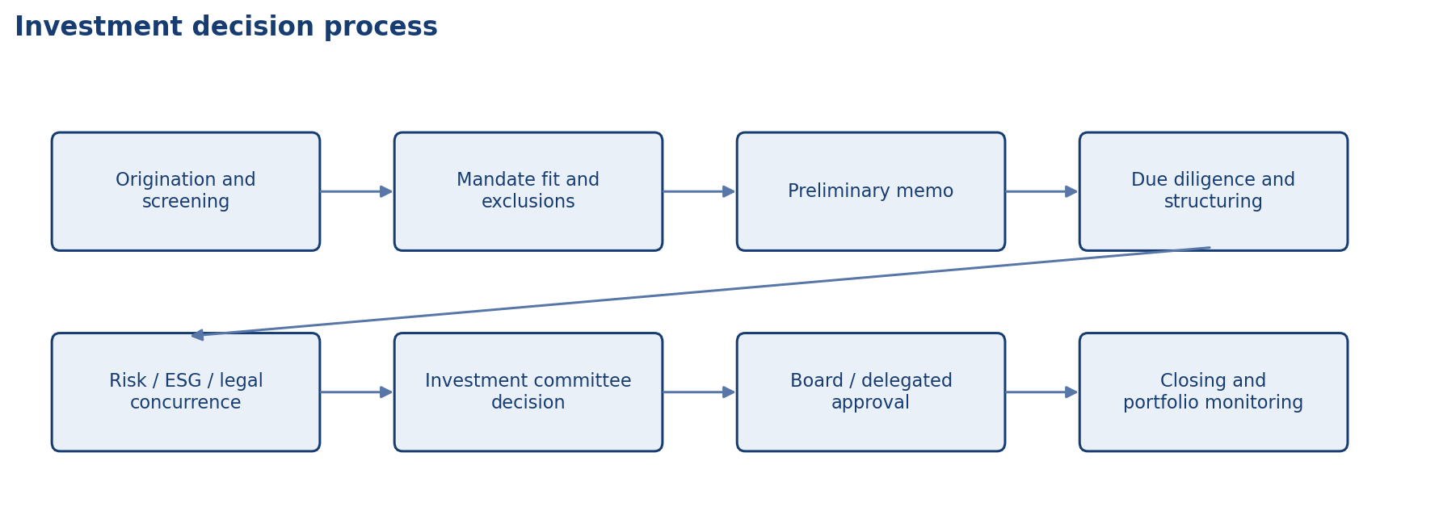
Investment decision process

Scope and application
Unless expressly excluded in writing, this document applies to NCDF Holdings Limited, controlled subsidiaries, regulated entities, managed funds, project SPVs, corporate functions, country or state programmes, and staff or contractors acting on behalf of the Group. Where a fund constitution, shareholder agreement, regulatory licence or concession agreement imposes an additional requirement, management shall reconcile the difference in favour of the stricter or more specific control.

Authority and approval
This document is issued under the authority of the NCDF Group Board and, where applicable, applies through delegated authority to the Board committees, management committees, regulated entities, fund vehicles, special purpose vehicles and controlled subsidiaries. Where local law, fund documentation or regulatory licence conditions impose stricter requirements, the stricter standard prevails.

Definitions and interpretive principles
For the purposes of this document, 'Board' means the board of the relevant NCDF entity; 'Group' means NCDF Holdings Limited together with controlled entities, programmes and managed vehicles; 'material' means any matter that could reasonably influence an investor, regulator, counterparty or stakeholder decision; and 'three lines' refers to business ownership of risk, independent oversight, and independent assurance.

Framework purpose
The Investment Decision Framework sets out the mandatory process, decision rights and evidence standards for evaluating and approving investments, project financings, structured transactions, co-investments, strategic partnerships and asset allocations across the NCDF ecosystem. The framework is intended to reduce bias, strengthen comparability and ensure that commercial ambition is balanced by discipline.

Investment principles
Every investment must satisfy mandate fit, strategic rationale, risk-return discipline, legal and regulatory permissibility, integrity checks, E&S screening and realistic execution capability. Development impact does not substitute for deficient governance or unbankable structure; equally, purely financial attractiveness is insufficient where conduct, social licence or safeguards are weak.

Stage-gate architecture
Transactions should pass through staged decision gates: origination and initial screen; concept approval for resources to be spent; due diligence and structuring; final approval; conditions precedent and closing; post-investment monitoring; and exit or value-realisation review. Each stage should have explicit decision makers, required evidence and stop/go criteria.

Due diligence requirements
At minimum, due diligence should address legal title and capacity; sponsor and management integrity; financial model and sensitivities; market demand and competitive context; technical feasibility; permits and land issues; tax and structuring; insurance; ESG and stakeholder issues; procurement risks; fraud and sanctions checks; and downside scenarios, including recovery options.

Approval standards
Recommendations should distinguish key assumptions, base and downside cases, value drivers, control mitigants, covenant package, information rights, conflicts analysis and implementation plan. Concurrence or no-objection requirements should be defined for risk, legal, compliance, finance, tax, ESG / ESMS and, where relevant, treasury.

Post-approval discipline
Approval is not the end of governance. Transactions must move into monitored implementation with conditions tracking, covenant compliance, valuation review, watchlist escalation, incident reporting and lessons-learned capture. Material deviations from approval assumptions should trigger escalation to the approving authority or a higher body, depending on threshold.

Roles and responsibilities

Responsibility matrix
Gate | Minimum output
Initial screening | Mandate fit, exclusions, headline risks and resource request.
Diligence approval | Structured workplan and accountability for analysis.
Final approval | Full paper with legal, financial, risk, ESG and execution view.
Closing | Conditions precedent tracker and final legal confirmations.
Monitoring | Watchlist, valuation and covenant reporting.

Operating protocol
The following minimum operating protocol shall apply unless a stricter procedure is approved for the relevant entity or transaction type.
• Use approved templates, registers and agenda structures so decisions are comparable over time and across entities.
• Maintain documented evidence of review, challenge, concurrence, approval and implementation tracking.
• Escalate exceptions, overdue actions, threshold breaches and material incidents promptly to the designated authority.
• Retain records in a controlled repository with version history, ownership and access controls.
• Provide periodic attestation or reporting to the Board or relevant committee on implementation effectiveness.

Minimum recurring deliverables
Deliverable | Typical owner | Frequency | Primary audience
Policy / charter review | Policy owner + Company Secretary | Annual | Board or committee
Management information pack | Relevant executive / control function | Quarterly | Board / committee / management forum
Training and awareness evidence | Compliance / Risk / Secretariat / HR | Annual | Board committee and internal audit
Exception and remediation log | Process owner | Monthly / quarterly | Executive management and relevant committee
Independent assurance activity | Internal Audit / external specialist | Risk-based plan | Audit & Risk Committee / Board

Implementation, review and records
Management shall maintain procedures, templates, registers and evidence necessary to implement this document in a manner capable of external review. The Company Secretary or designated policy owner shall maintain the approved master copy, revision history, approval minute references, and distribution controls for all controlled versions.

Minimum governance artefacts
Artefact | Owner | Minimum frequency | Evidence
Board or committee workplan | Company Secretary / Chair | Annual | Approved calendar and agenda pack
Policy attestation or acknowledgement | People & Culture / Compliance | Annual | Signed attestations or system logs
Training and awareness | Compliance / Risk / Secretariat | At onboarding and annually | Attendance logs and materials
Exception register | Policy owner | As needed | Documented waivers and remediation actions
Board reporting | Relevant executive owner | Quarterly | Board / committee papers

Appendix: document control summary

Control sheet
Field | Entry
Document status | Institutional policy / charter / framework
Primary audience | Board, management, regulated entities, fund governance teams and diligence stakeholders
Review trigger events | Regulatory change, major transaction, operating model change, control failure, external assurance finding or Board instruction
Related documents | Code of business conduct and ethics, disclosure policy, delegated authorities, risk governance, committee charters, ESMS, AML/KYC, procurement and compliance procedures
Retention expectation | Retain current and superseded versions in controlled corporate records repository

